**Adding a new Areal Feature**

The References page 'List of Areal Features' displays all the areal features defined by the GSI Cost Tool 'super user'.

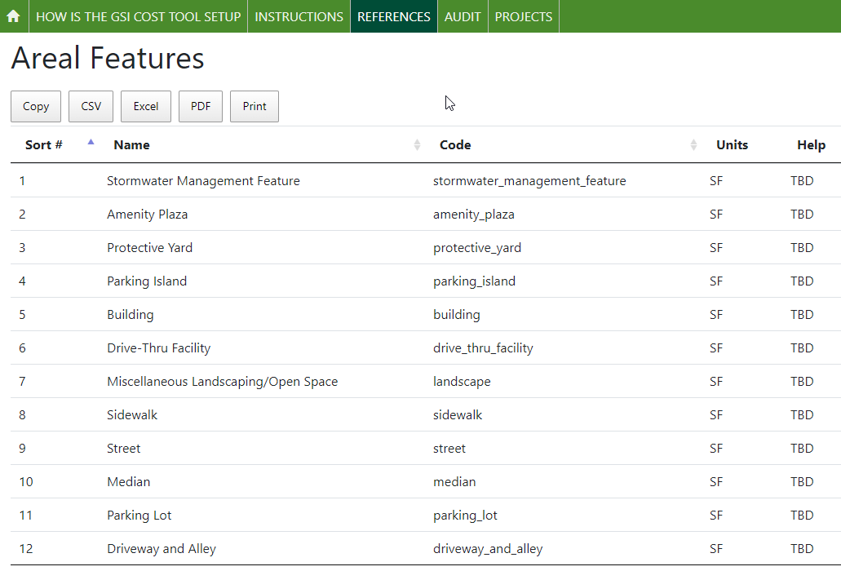

Note: *for each Areal Feature the 'code' and the 'Name' are unique.*

**Note:** *Once an Areal Feature has been created, and used by users, it should not be deleted. It can be updated – by changing the Name and or Code, but this will change the values displayed in all the Scenarios that already exist..*

New values are entered using the 'GSI Cost Tool Admin Page', which is only available to users who have been granted 'superuser' status. In the image below, the user has superuser status. When a superuser logs into the GSI Cost Tool, the menu in the upper right corner of the screen has 3 options. Use the first option to open the 'GSI Cost Tool Admin Page'

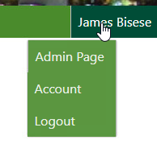

On the GSI Cost Tool Admin Page the administrator can add, edit, and delete data. The administrator can select any option by selecting the name of the option, or the 'Change' menu button.

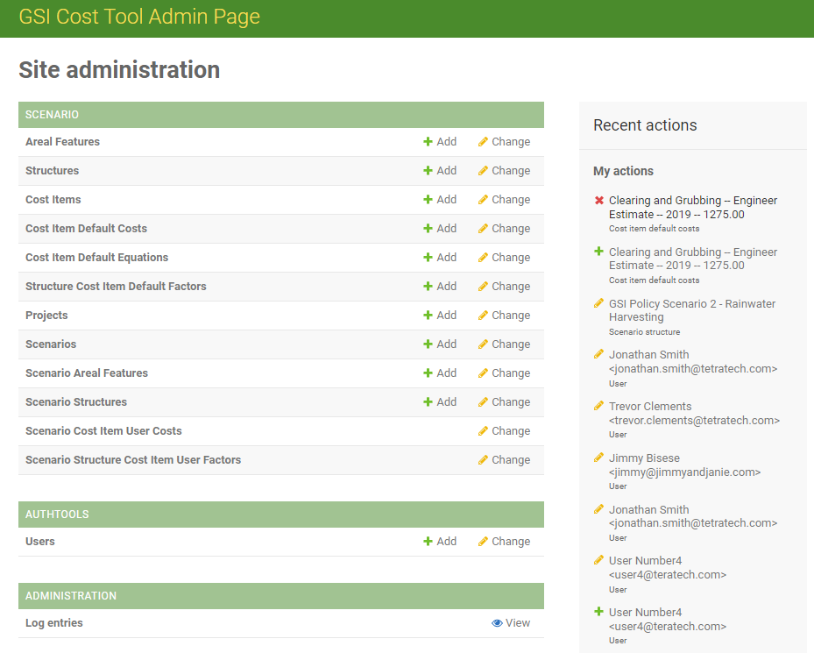

To review, and create, new Areal Features, select the option from the Site administration list. The information displayed on the admin page is the same shown in the Reference page.

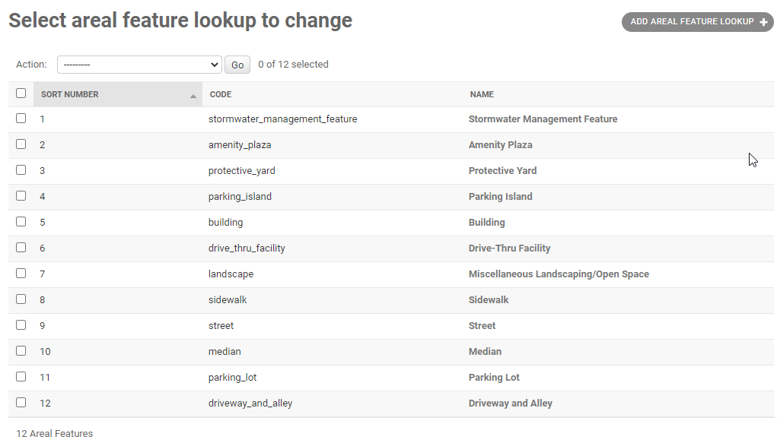

To create new value – use the button 'ADD AREAL FEATURE' in the upper right corner.

In the screen that opens, enter the information for the new areal feature. Then hit the SAVE button on the lower right corner of the screen.

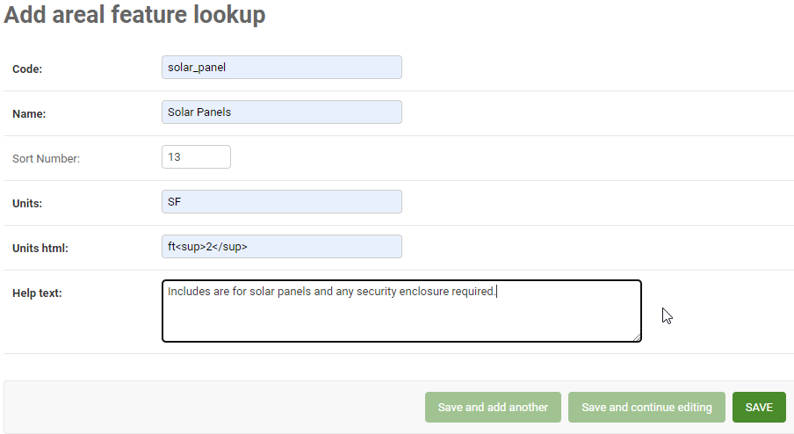

On the list of cost item default costs, the new entry should be displayed in a banner, and then added to the list.

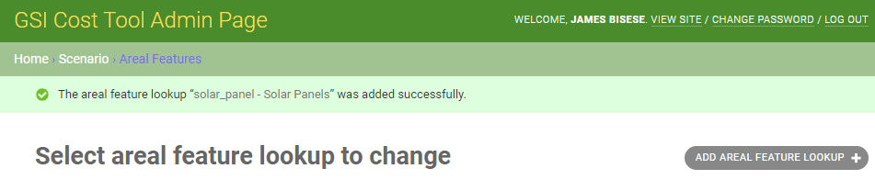



The new value will also be displayed to users in the GSI Cost Tool – on the Project-Scenario Description tab in the list of Scenario Areal Features.

